PSG COLLEGE OF TECHNOLOGY, COIMBATORE – 641 004

DEPARTMENT OF APPLIED MATHEMATICS AND COMPUTATIONAL SCIENCES

18XW47 – Mathematical Computing Lab – Final Lab Test

21.04.21 Duration : 60 minutes

Instructions :

1. Write the model in a white paper. Scan it and upload within 30 minutes. After that you cannot upload. Time will not be extended. After uploading the model, you can start coding.
2. Upload the R script in next 30 minutes. Don’t Zip.

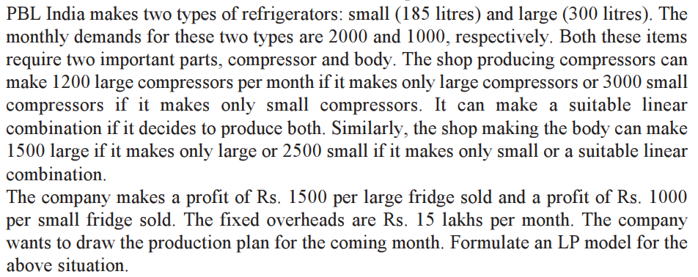

i. Write the model.

ii. Write a R script to solve the above problem using simplex method.

iii. Determine the dual prices.